Week 3 - Week commencing 14/2/2022

**Outline**

Online meeting to discuss the next step of the project: calculating the response and Noise – equivalent temperature (NET). Following from last week, the dF0 can now be used to find a response of the detector. Using the measurements from week 1, the hot bar is a known temperature T. We can obtain a responsivity based on dF0/dT.

The dF0 can be calculated by identifying the peak of hot bar that takes the shape of a Gaussian curve, where the location and where it is is explained in the previous week. The peak can have a Gaussian curve fitted on it and the peak height can be found, this is the dF0.

Next, the dT can be found by determining the change in temperature of the hotbar and the room. This is just the difference between the temperatures measured in week 1. The response can simply be calculated from these values and the process can be repeated for the other KIDs.

Finally, the NET is related to the response by:

$$NET =\frac{\sqrt{e_{n}}}{Response}$$

Where $e_{n}$ is the spectral density. This value can be found by taking the Fourier Transform of the dF0 values and finding the intensities of each frequency bin, then use this value to calculate NET.

**Complete Python Code Attached at the End of Diary**

**Tasks Outline**

* Find the peak height of the hot bar feature.
* Calculate a response using the peak height and hotbar temperature
* Take the Fourier Transform of the dF0 data to find the spectral densities
* Find NET using spectral densities and response

**

A Gaussian was fitted to the hot bar feature of KID 2 and using the Python’s curve fit function, the parameters for the height of the curve can be found, which is the peak height.

The response for KID 2 was found to be 27.5 Hz/K

**Responsivities of all KIDs Graph**

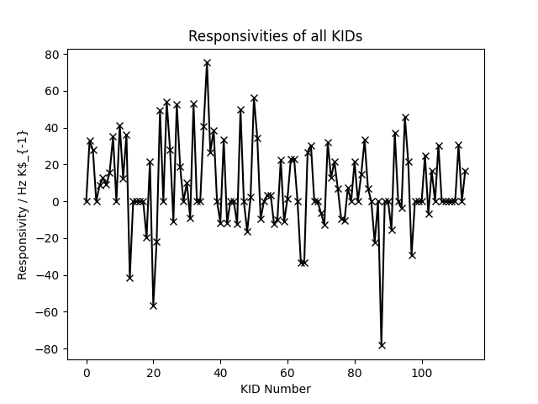

The process was looped in Python for the other KIDs. The values exceeding a magnitude of 100 was set to 0. This was probably due to a change in the shape of the curve causing distortions. This can be fixed in a future week.

**Graph of NET vs Frequency for KID 2**

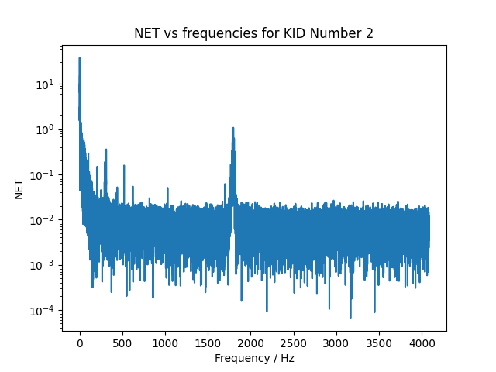

The Fourier Transform of the dF0 data for KID 2 was taken and the spectral densities found. Then, using the densities, found NET using the mentioned formula. NOTE: NET =/= NEP. To find NEP, calculate power of bar. 1/f noise and hotbar feature evident. The white noise level is also deducible.